Name : Lokesh Jayvant Chavan Date :

Subject Name : Lab on MCT Practical No : 08

Practical Name : Create an Android application for sending SMS.

***************************************************************************

**activity_main.xml**

<?xml version="1.0" encoding="utf-8"?>  
<LinearLayout xmlns:android="http://schemas.android.com/apk/res/android"  
 android:orientation="vertical" android:layout_width="match_parent"  
 android:layout_height="match_parent">  
 <TextView  
 android:id="@+id/fstTxt"  
 android:layout_width="wrap_content"  
 android:layout_height="wrap_content"  
 android:layout_marginLeft="100dp"  
 android:layout_marginTop="150dp"  
 android:text="Mobile No" />  
 <EditText  
 android:id="@+id/mblTxt"  
 android:layout_width="wrap_content"  
 android:layout_height="wrap_content"  
 android:layout_marginLeft="100dp"  
 android:ems="10"/>  
  
 <TextView  
 android:id="@+id/secTxt"  
 android:layout_width="wrap_content"  
 android:layout_height="wrap_content"  
 android:text="Message"  
 android:layout_marginLeft="100dp" />  
 <EditText  
 android:id="@+id/msgTxt"  
 android:layout_width="wrap_content"  
 android:layout_height="wrap_content"  
 android:layout_marginLeft="100dp"  
 android:ems="10" />  
  
 <Button  
 android:id="@+id/btnSend"  
 android:layout_width="wrap_content"  
 android:layout_height="wrap_content"  
 android:layout_marginLeft="100dp"  
 android:text="Send SMS"  
 android:onClick="sendsms" />  
</LinearLayout>

**MainActivity.java**

package com.example.sms;  
  
import androidx.appcompat.app.AppCompatActivity;  
  
import android.Manifest;  
import android.content.pm.PackageManager;  
import android.os.Build;  
import android.os.Bundle;  
import android.telephony.SmsManager;  
import android.view.View;  
import android.widget.Button;  
import android.widget.EditText;  
import android.widget.Toast;  
  
public class MainActivity extends AppCompatActivity {  
 EditText phonenumber, message;  
 Button send;  
  
 @Override  
 protected void onCreate(Bundle savedInstanceState) {  
 super.onCreate(savedInstanceState);  
 setContentView(R.layout.activity_main);  
  
 send = findViewById(R.id.btnSend);  
 phonenumber = findViewById(R.id.mblTxt);  
 message = findViewById(R.id.msgTxt);  
 send.setOnClickListener(new View.OnClickListener() {  
  
 public void onClick(View v) {  
  
 if (Build.VERSION.SDK_INT >= Build.VERSION_CODES.M) {  
 if (checkSelfPermission(Manifest.permission.SEND_SMS) == PackageManager.PERMISSION_GRANTED) {  
 sendsms();  
 } else {  
 requestPermissions(new String[]{Manifest.permission.SEND_SMS},1);  
  
 }  
  
 }  
 }  
  
 });  
 }  
  
 private void sendsms() {  
 String number = phonenumber.getText().toString().trim();  
 String msg = message.getText().toString().trim();  
 try {  
 SmsManager smsManager = SmsManager.getDefault();  
 smsManager.sendTextMessage(number, null, msg, null, null);  
 Toast.makeText(getApplicationContext(), "Message Sent", Toast.LENGTH_LONG).show();  
 } catch (Exception e) {  
 e.printStackTrace();  
 Toast.makeText(getApplicationContext(), "Some fiedls is Empty", Toast.LENGTH_LONG).show();  
 }  
  
  
 }  
}

**AndroidMainfest.xml**

<?xml version="1.0" encoding="utf-8"?>  
<manifest xmlns:android="http://schemas.android.com/apk/res/android">  
 <uses-permission android:name="android.permission.SEND_SMS"/>  
 <application  
 android:allowBackup="true"  
 android:icon="@mipmap/ic_launcher"  
 android:label="@string/app_name"  
 android:roundIcon="@mipmap/ic_launcher_round"  
 android:supportsRtl="true"  
 android:theme="@style/Theme.Sms">  
 <activity  
 android:name=".MainActivity"  
 android:exported="true">  
 <intent-filter>  
 <action android:name="android.intent.action.MAIN" />  
  
 <category android:name="android.intent.category.LAUNCHER" />  
 </intent-filter>  
 </activity>  
 </application>  
  
</manifest>

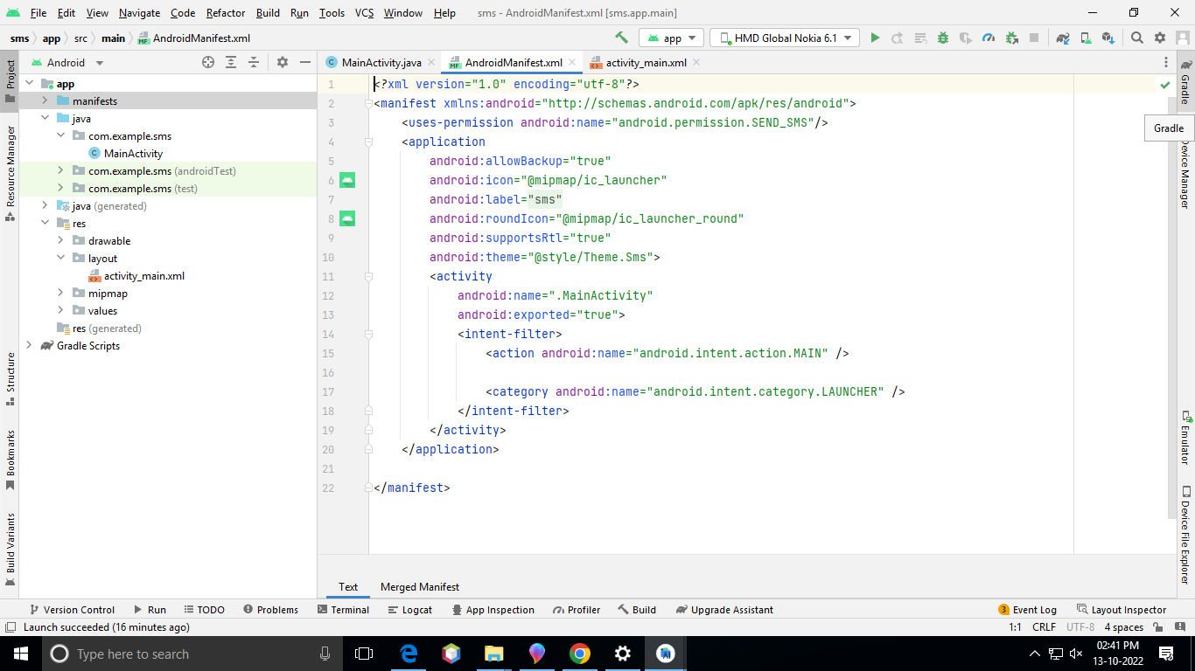

**Output :**

